DATE: 06.04.2018
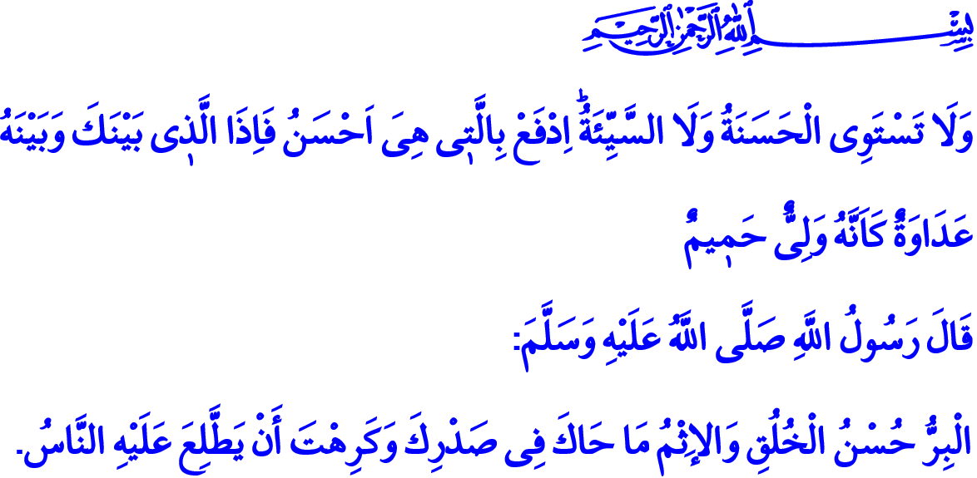
THE THING THAT INCREASES BY SHARING: GOODNESS
Jumu’ah Mubarak, Honorable Believers!
In the verse I recited, our Almighty Lord enjoins, “And not equal are the good deed and the bad. Repel [evil] by that which is better; and thereupon the one whom between you and him is enmity [will become] as though he was a devoted friend.”
Our Prophet (s.a.w.) states in the hadith I recited, “Righteousness is good behavior, and sin is what fluctuates in your chest, and you would hate that the people discovered it about you.”
Dear Brothers and Sisters!
Goodness is the most basic aim of creation. Allah, who has created mankind, who sustains, protects and forgives man and covers him with His grace, has created death and life to test who amongst us does better deeds.
The life we experience is a journey of goodness. Man is a traveler who came to this world to believe and do good deeds. Man exists to perform good, beneficial and virtuous acts, and to show righteous and kind behavior. It is man’s first duty to both avoid and prevent acts of evil, wrongdoing and harm.
Honorable Believers!
Goodness is simply the name of the character that faith and all acts of worship seek to impress on us. Goodness is all values that make us human. And the most important feature that our faith seeks us to be is being good believers, good children, good parents, good neighbors, good friends, i.e. being good persons.
Goodness is a call to faith and Islam. Sometimes it is high morality, virtue and good temper. Sometimes it is charity, sadaqah and zakat. Goodness is at times a smile and an embrace, a kind word and a smiling face. Goodness is the endeavor to be good and spread good deeds with good companions. It is the highest rank of faith and worship.
Esteemed Muslims!
Goodness is to be a companion for the lonely, a shoulder on which the tired may rest, a shelter for the needy. It is embracing refugees, protecting orphans, helping the elderly. Goodness is to give without expecting anything in return; to share one’s strength, experience, wealth, love and mercy without the expectation of material benefit.
Goodness is compassion, sacrifice, justice, and affection. It requires to be at the side of the oppressed and against the oppressors. Goodness is supplication, invocation, and greeting. A pair of hands joining in saying “Ameen” at a time of trouble is goodness. A good deed is sometimes planting a tree, at others it is feeding a hungry animal. It is the meal shared with one’s neighbors, and giving directions to those who are lost.
Dear Believers!
The Islamic civilization has been carrying on the movements of charity and relief for centuries. Countless charity foundations have been established for this purpose. Our nation has been a refuge for the wronged and the ansar to the muhajirun through these organizations.
Esteemed Believers!
Unfortunately, good acts are passed over for evil ones in the memory of our time. Evil is besieging our world day by day and mankind is losing its high values such as conscience, justice, compassion and mercy each passing day.
In such a world, it must be the ideal of us all to make goodness dominant and to prevent evil. Because it is a tenet of our faith to say “No more!” to evil with our hands, tongues, and hearts. Let us not forget that  “Good deeds do away with misdeeds.” And evil takes over the place of every good deed we neglect.
Honorable Believers!
Let us call upon Allah in this auspicious day and say: Oh Lord! Render us amongst your fortunate servants who can build bridges of goodness and mercy between our hearts!
Our Lord, give us in this world [that which is] good and in the Hereafter [that which is] good and protect us from the punishment of the Fire! Our Lord! Forgive us and our parents and the believers on the Day the account is established!

Fussilat, 41/34.
Muslim, Birr, 14.
Mulk, 67/2.
Hud, 11/114.
Baqarah, 2/201.
Ibrahim, 14/41. General Directorate of Religious Services

